British Airways

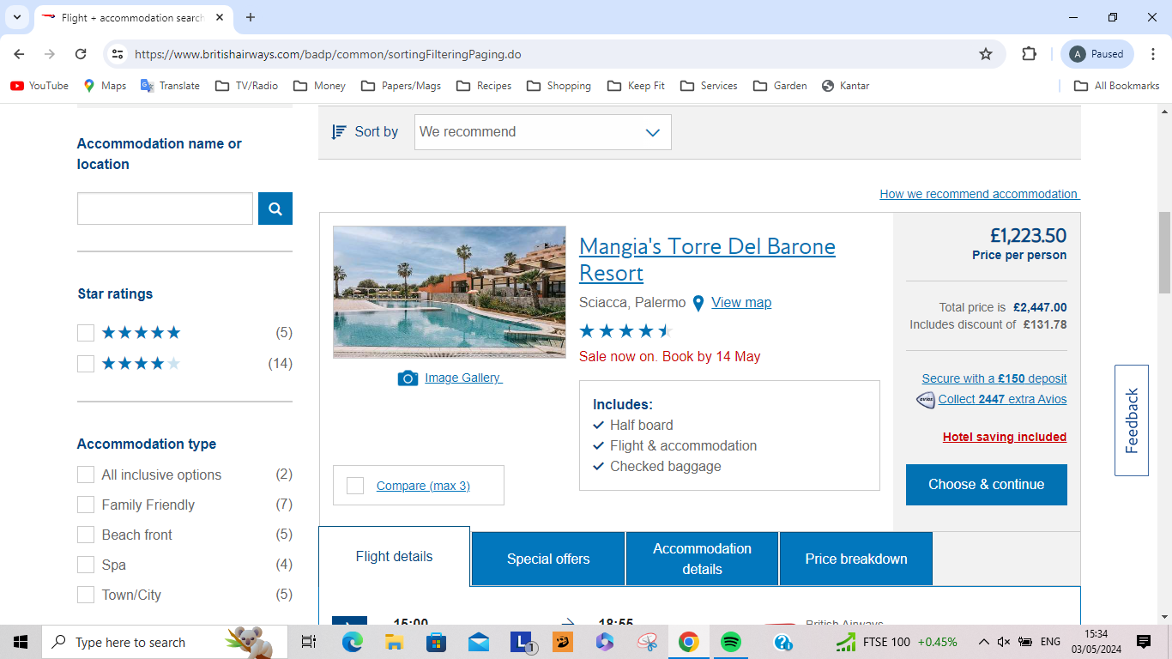

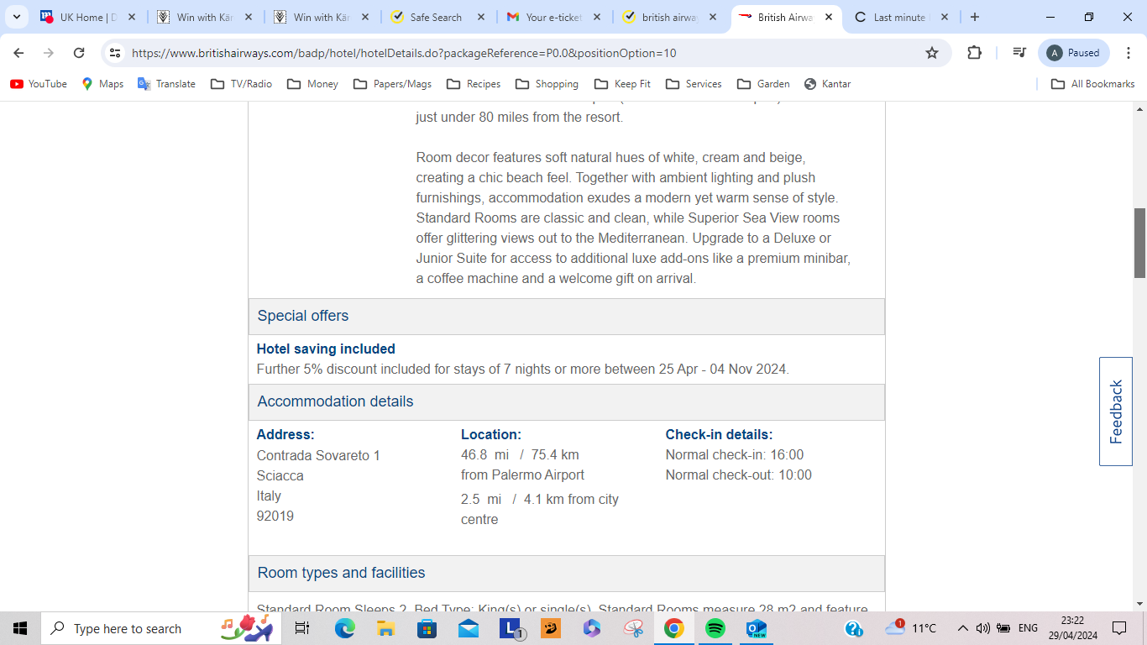

The port town of Sciacca is just three and a half miles west along the coast. You’ll find a charming marina, the rustic streets of the old town and Luna castle here. Palermo Airport (Falcone Borsellino Airport) is situated just under 80 miles from the resort.

